2 SYSTEM ANALYSIS

2.1 STUDY OF CURRENT SYSTEM

In the olden days’ students had to visit the college to enquire about details and other information about the college, which is a time-consuming process as well as lengthy procedure for both parents as well as students. Nowadays there are many changes occurred in the Education system with help of advanced technological improvements. Everything is happening over the internet without any difficulty.

In those days for submitting a small application also, we have to visit that place, but as the days are passing away it’s completing changing. Collecting the applications manually will be hectic procedure and it also needs a manpower. For reducing that manpower and such difficulties many devices or systems were emerged day by day.

2.2 Problem and weakness of Current System

Due to the lack of information many students faced problems in paying fees and thus deadlines gets passes and they have to pay penalty fees. Same problem occurred in filling of the scholarship form.

This system fails to provide quick guidance. We have to go to the college for collecting of the information regarding any problems.

2.3 Requirement Analysis

Tools used:

# A computer system running on Windows

# Notepad++ used for editing the python, XML or HTML code.

# NLTK, AIML, FLASK packages in python 3.

# OpenNLP

# Web Browser (Chrome)

Techniques, Languages used: # HTML, CSS, JavaScript

#XML(AIML framework)

#SQLITE

#Parsing and Substitution, the same which is used in Eliza.

#POSTagging NLP(Natural Language Processing)

#Database Management System

2.4 Brief literature review and Prior Art Search (PAS) about the project

Components of ChatBot Application

The main components of the ChatBot are:

• UI

• Back-end

UI: The user interface is simple with not much colors. It is kept as simple as possible so as to make it look like a college chatbot. It consists of a text box at the bottom where the user may write the queries. A “send” button is placed in order to send the query to the bot. The UI is created using HTML, CSS and Javascript.

Background Working:

There are three phases: Parsing and Substitution Natural Language Processing Database Parsing and Substitution:

Whenever a user types a query, it is passes on to a class which parses the input and then substitutes words and phrases with other words and phrases so that a statement which is grammatically correct can be generated. It is carried out using XML and Python.

Natural Language Processing: NLP is required so that the data which is parsed can be “understood” by the application. For e.g. a user’s humor, feelings, names and places mentioned in the input. NLP is not implemented in the project but can be implemented if needed in the future.

Database: There are various database files in the database folder with “.aiml” extension. These are the files which contain the various patterns of the conversations.

NLP is a part of artificial intelligence which deals with human languages. It has the following structure:

# Application

# NLP layer

# Knowledge Base

# Data Storage

NLP is divided into two very important components:

# Natural Language Understanding: It is mostly used to map inputs to useful representations. It is also helpful in analyzing different aspects of the language.

# Natural Language Generation: It is generally used text planning, sentence planning, and text realization. NLP is implemented using a library in Python named NLTK. There are some steps followed in NLP:

# Tokenization: It is the process to break a complex sentence into words. Also, the importance of each word is understood with respect to the sentence. It also helps to produce a structural description on an input sentence.

# Stemming: It is the process in which words are normalized into its base form or root form.

# Lemmatization: It is the process in which grouping of different inflected forms of a word is done. It also roots several words into one common root but the output of Lemmatization is a proper word.

# Stop Words: These are some of the words which are helpful to make a sentence meaningful but do not help in NLP.

# Parts of Speech: It is an inbuilt library containing the various parts of speech.

2.5 Design: Analysis, Design Methodology and Implementation Strategy



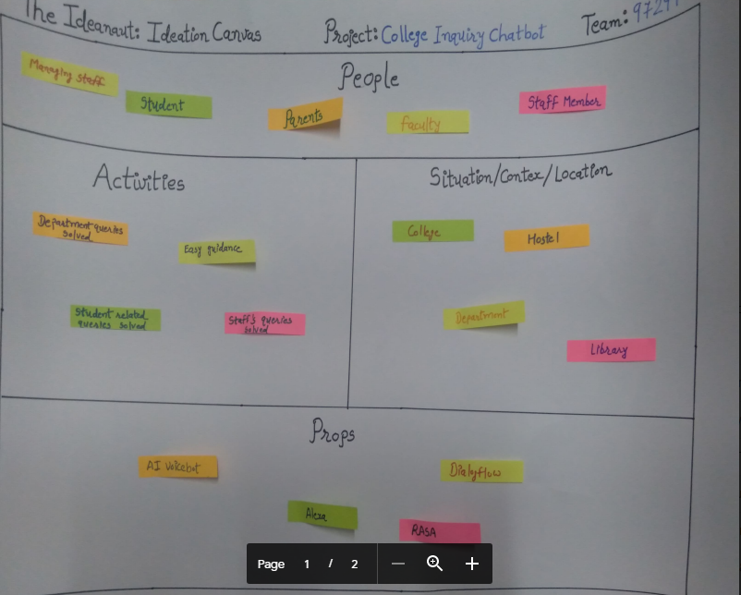

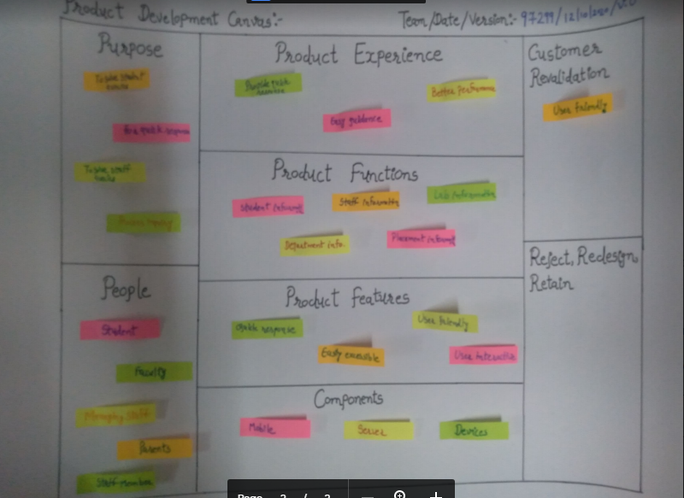

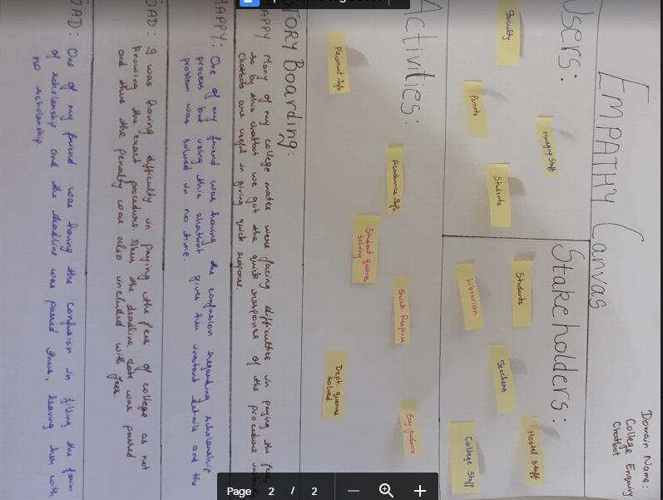

4 System Modeling:

4.1 Dataflow Diagrams:

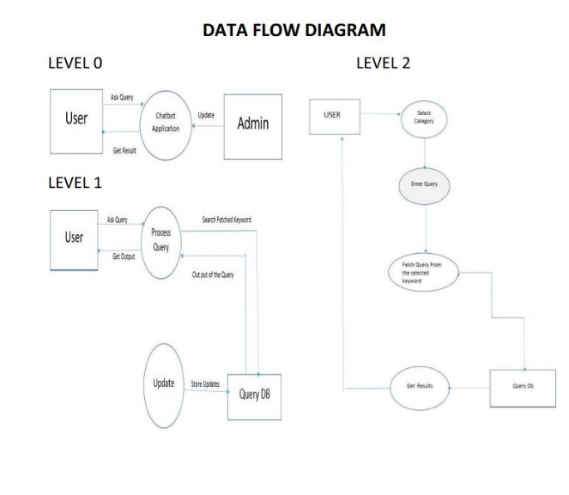  
https://www.geeksforgeeks.org/project-idea-amanda-smart-enquiry-chatbot/

4.2 Use case Diagram:

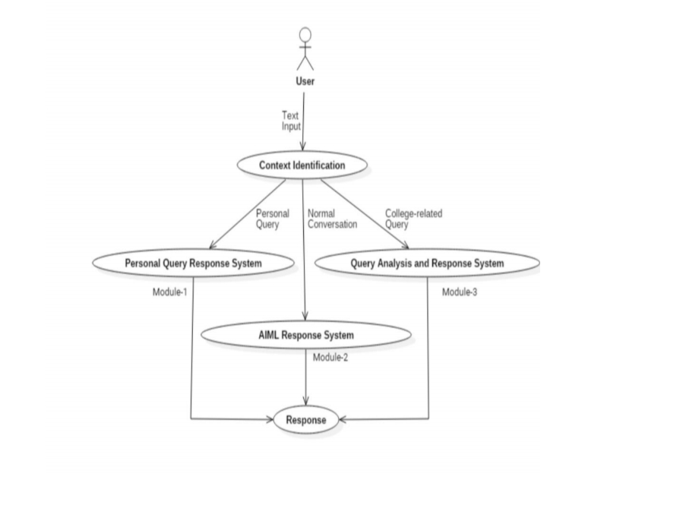

This type of enquiry chatbot is very useful for students, faculty, managing faculty and parents. This chatbot can reply all user queries regarding college, form-process, department, subjects etc. This chatbot can reply the user quickly and efficiently.

4.3 Activity Diagram:

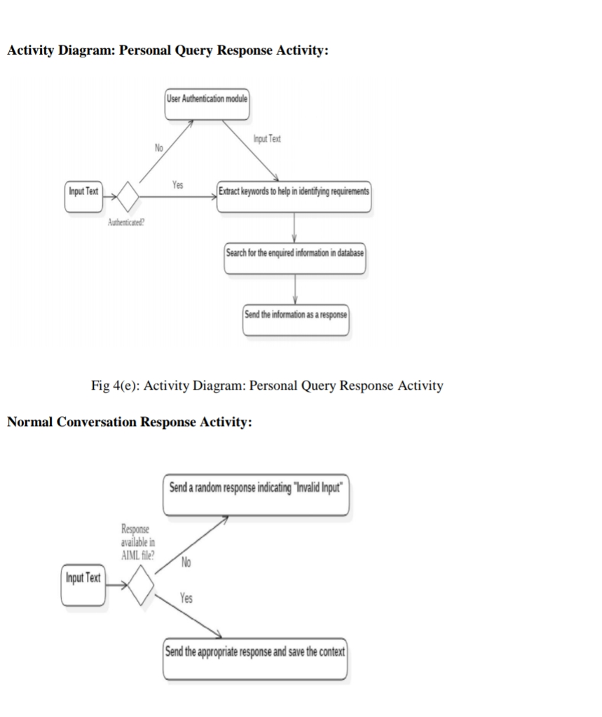

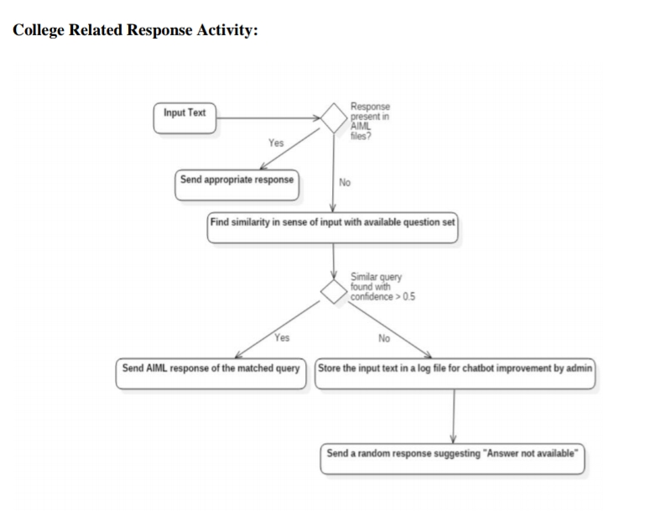4.4 Sequence Diagram:

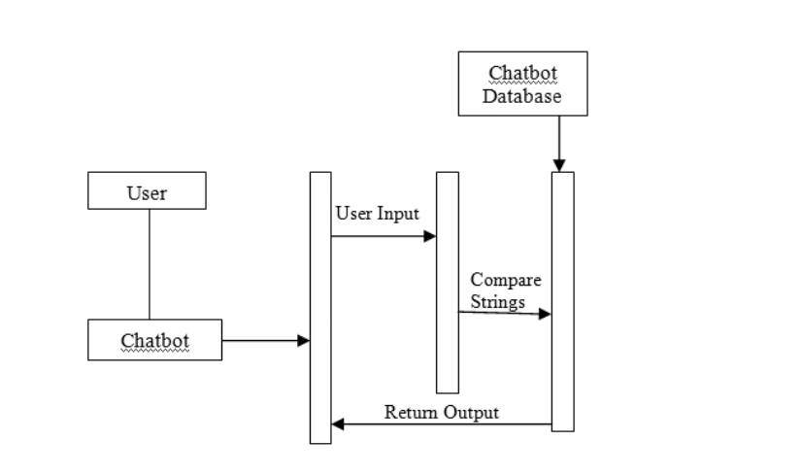

<https://www.researchgate.net/figure/Sequence-Diagram-Representing-Design-of-the-Chatbot_fig1_321864990>

https://images.app.goo.gl/Tbmu9vbNMFRaVRd4A

4.5 State Diagram:

https://images.app.goo.gl/XGXWW8Kj1P74jhdKA

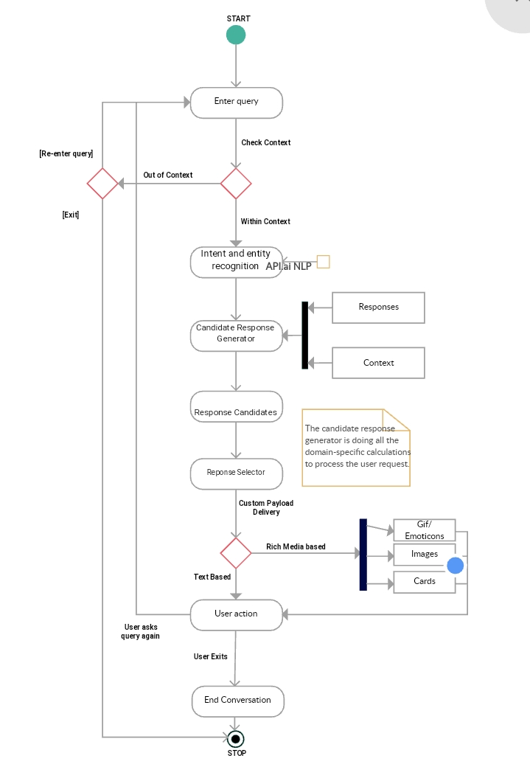

4.6 Class Diagram:

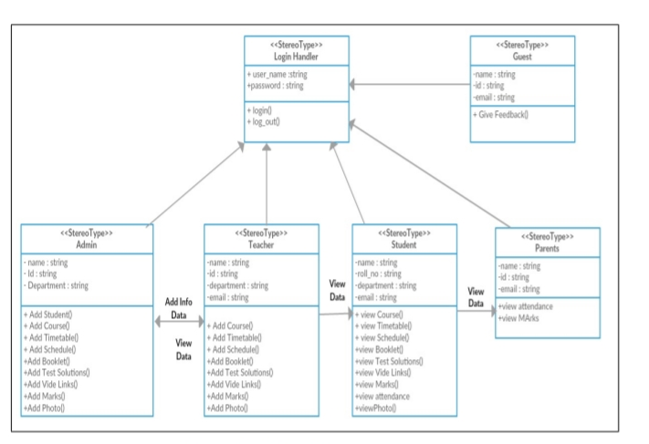

4.8 System Architecture Diagram:

